Fall 2004 Zen Retreats at Mu Sang Sa

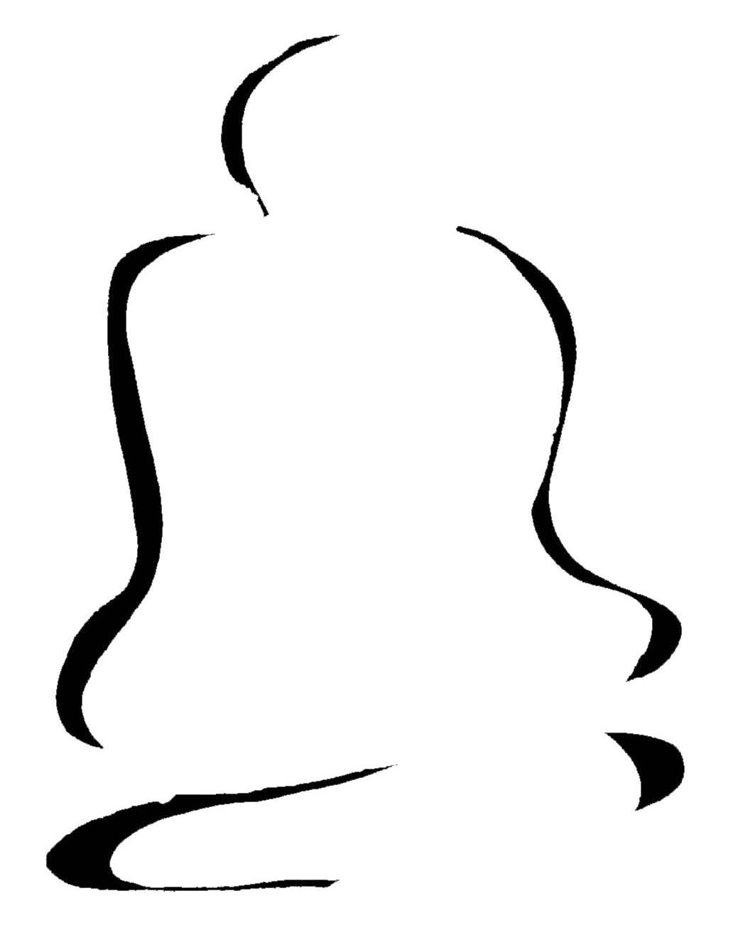

“Life is short. Please examine it very carefully.”
The Buddha

This fall, take time to sit a short meditation retreat at Mu Sang Sa, an international Zen temple located at the head of the dragon on Kye Ryong San, Korea. Nestled in a pine forest, it looks down a valley of rice fields. Everyone practices together and benefits from the strong mountain energy, fresh air and clear spring water. You will also have an opportunity to practice in the beautiful new wooden Buddha Hall.

During these retreats, all participants will be given full instructions on practicing, have kong-an interviews and attend Dharma talks given by our Abbot and Guiding Teacher Mu Shim Sunim, JDPS.

Everyone is welcome to join these retreats and we look forward to hearing from you.



Chusok Holiday Retreat

September 25 – 28, 2004 (4 days)
Guiding Teacher: Mu Shim Sunim JDPS

Start: 12:30 p.m. Saturday, Sept 25, 2004
End: Afternoon, Tuesday, Sept. 28, 2004
Retreat Fee: 100,000 Won
Places: 40 participants



Please click here for an APPLICATION form and return to the Director.

Visit our website www.musangsa.org for more information

** Please book or buy your tickets early if you plan to use public transport to come for the retreat as the tickets sell out very quickly for the Chusok period.

계룡산 국제선원 무상사
Kye Ryong San International Zen Center Mu Sang Sa
Chungnam-do, Kyeryong-shi, Duma-myon, Hyanghan-ri, 452-13, South Korea 321-917
Tel: +82-42-841 6084 Fax: +82-42-841 1202 www.musangsa.org e-mail: info@musangsa.org

